Web-Based Student Academic Requisition Form with PDF Generation
Short Project Report
Student / Group: ______________________ Class: __________ Date: __________

1. Objective
To build a Python web application in which a student fills in the institute’s Student Academic Requisition Form online, accepts the student declaration, and downloads the completed form as a PDF that follows the official form’s layout. The HoD and Principal-office sections remain blank for the institute’s further processing.

2. Technology Used
Component | Choice | Reason
Web framework | Streamlit | Fast, pure-Python forms and tabs; free deployment on Streamlit Community Cloud
PDF engine | ReportLab | Exact coordinate-level control, needed to reproduce the form’s boxes, ruled lines and check-boxes
Storage | SQLite | Serverless, transactional; allows atomic requisition numbering and search
Imaging | Pillow, pypdfium2 | Signature clean-up; in-app preview of the generated PDF
Testing | pytest, Streamlit AppTest, Playwright | Unit, UI-flow and real-browser verification

3. System Design
Workflow: Open app → enter student details → select application type → enter purpose → supporting documents → accept declaration → Generate PDF → preview → Download PDF.
Modules
- app.py – user interface with three tabs: New Requisition, Track Status, Admin.
- validators.py – all validation rules; returns every error at once.
- pdf_generator.py – draws the form; database.py – SQLite layer; config.py – form wording and options.
Database. Table requisitions stores every field, status, remarks and the generated PDF; status_history stores each status change; counters produces gap-free numbers per year (REQ-2026-0001). Requisition number, record and PDF are created in one transaction, so a failed PDF leaves no orphan record.

4. PDF Generation – Fidelity to the Official Form
The original form was rendered and measured; the PDF reproduces its A4 page margins, bordered header with the institute logo and title, Department / Outward No. / Date line, the Processing Time note and sections 1 to 6 in the same order and wording, including the sentence “Application for – Bonafide / Student Certificate / … / Other request” in which the chosen option is highlighted. Entered values print in blue on the form’s lines. The following remain blank: Department Outward No., HoD Signature, HoD Remarks, Forwarded To, Signature / Remarks, Principal Decision, Principal Remarks and Principal Signature. A requisition number and a small QR code (requisition no. + roll no.) are added for office use.

5. Validation and Safety
- Mandatory: department, name, roll no., semester, division, email, mobile, application type, purpose, documents Yes/No, date.
- Mobile: valid 10-digit Indian number starting 6-9 (+91, spaces and hyphens accepted). Email: standard address format. Date cannot be in the future.
- Declaration must be ticked; “Other request” needs a description; if documents are attached, their names or files are required.
- Purpose (10-500 characters) and document names must physically fit the form, so nothing is silently cut off in the PDF.
- Uploads: limited by count, size and type, and the file content must match its extension; file names are sanitised; all SQL is parameterised.
- All times use the institute timezone (Asia/Kolkata), not the server’s UTC clock.

6. Features Beyond the Brief
Student: review-before-submit screen with a watermarked preview (a requisition number is issued only on confirmation) · duplicate-request warning · automatic requisition number and date · supporting-document upload · student signature upload · status tracking with history (needs requisition no. and roll no.) · withdraw a request · optional e-mail of the PDF and status changes · mobile-friendly interface · QR code on the PDF.
Staff: sign-in from the sidebar (the dashboard does not exist for students) · named accounts with an audit trail of who changed each status · login brute-force throttle · KPI cards and charts · SLA tracking against the form’s own 4-working-day promise, with overdue flags and filter · search and filters (text, status, type, department, date) · CSV export · access to each PDF and uploaded document.

7. Testing
51 automated tests cover validation (mobile/email edge cases), sequential numbering, rollback on failure, tracking rules, working-day/SLA arithmetic, duplicate detection, withdrawal rules, login throttle, spoofed-upload rejection, e-mail sending (mocked SMTP) and PDF content. The full user journey (validation errors → review → submit → download → track → withdraw → staff sign-in → dashboard) was also run in a real browser at desktop and phone sizes.

8. Screenshots
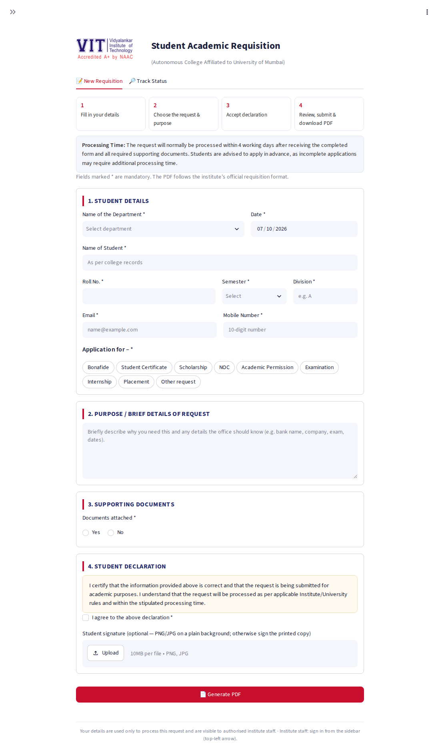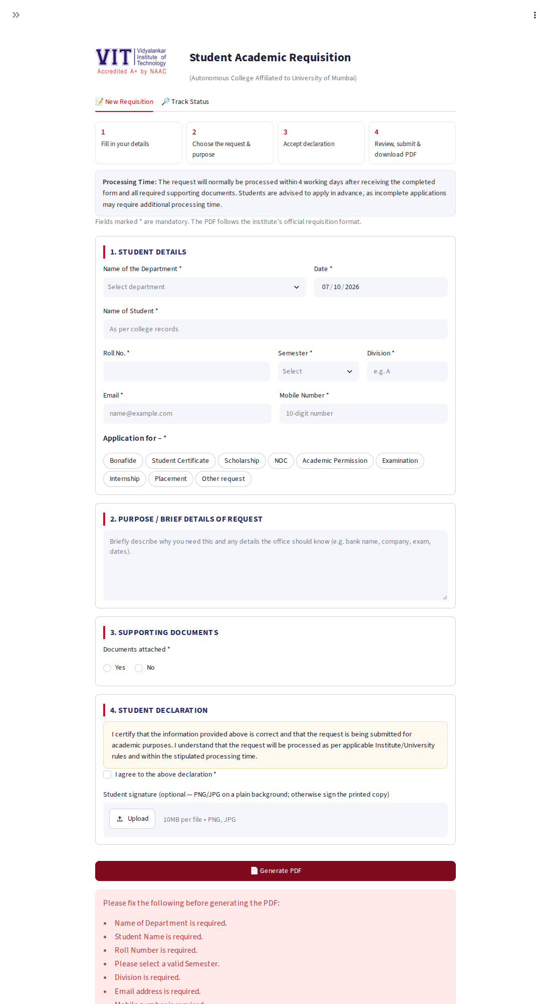
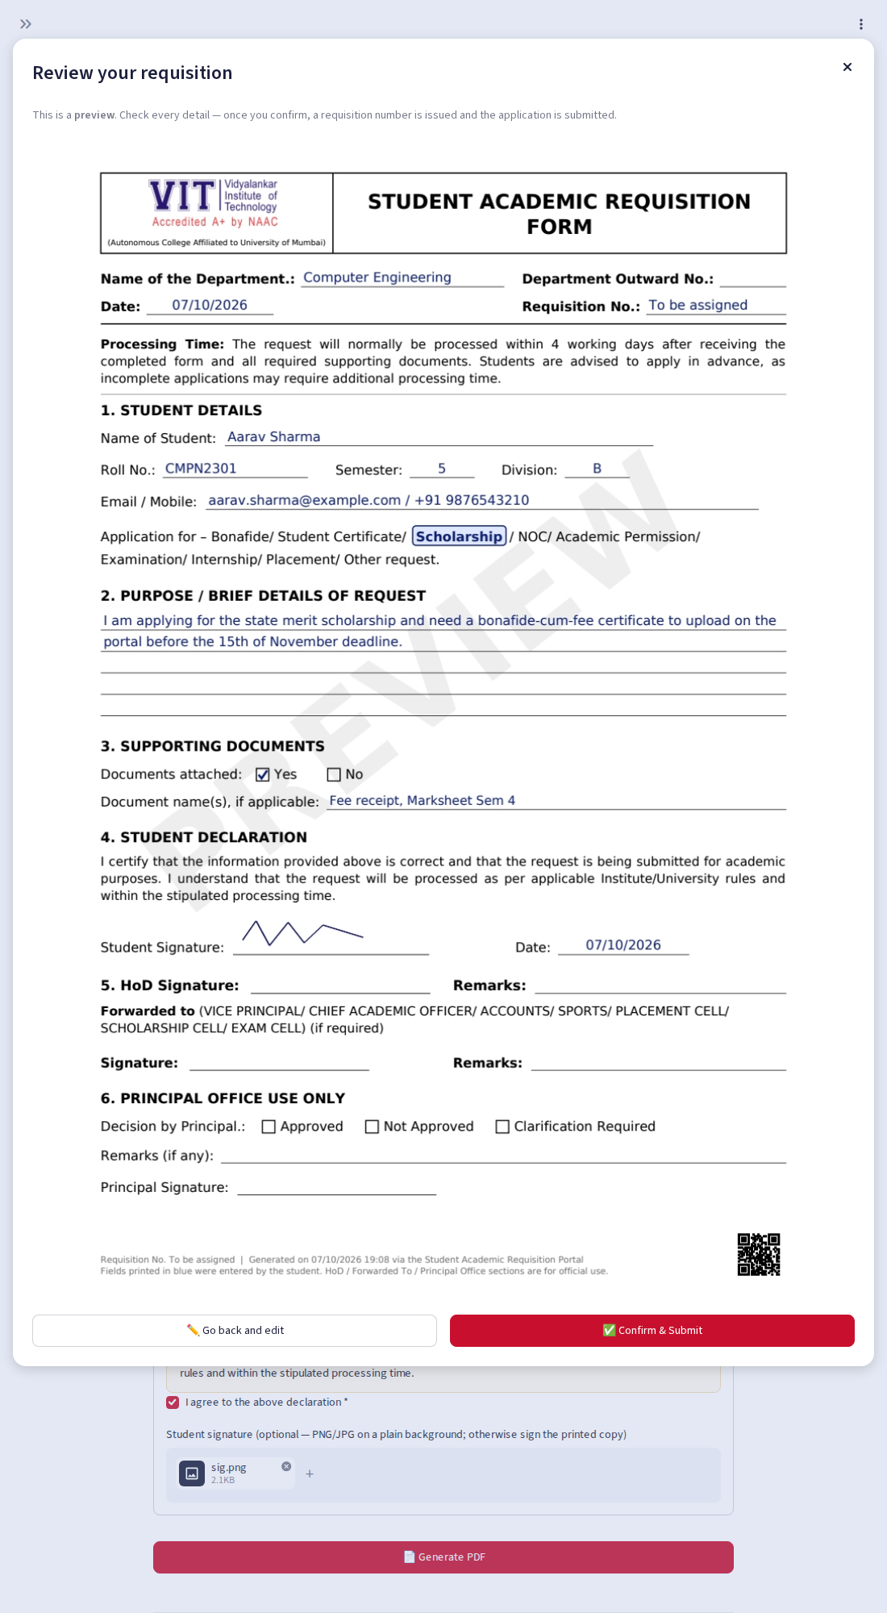
Review before submit
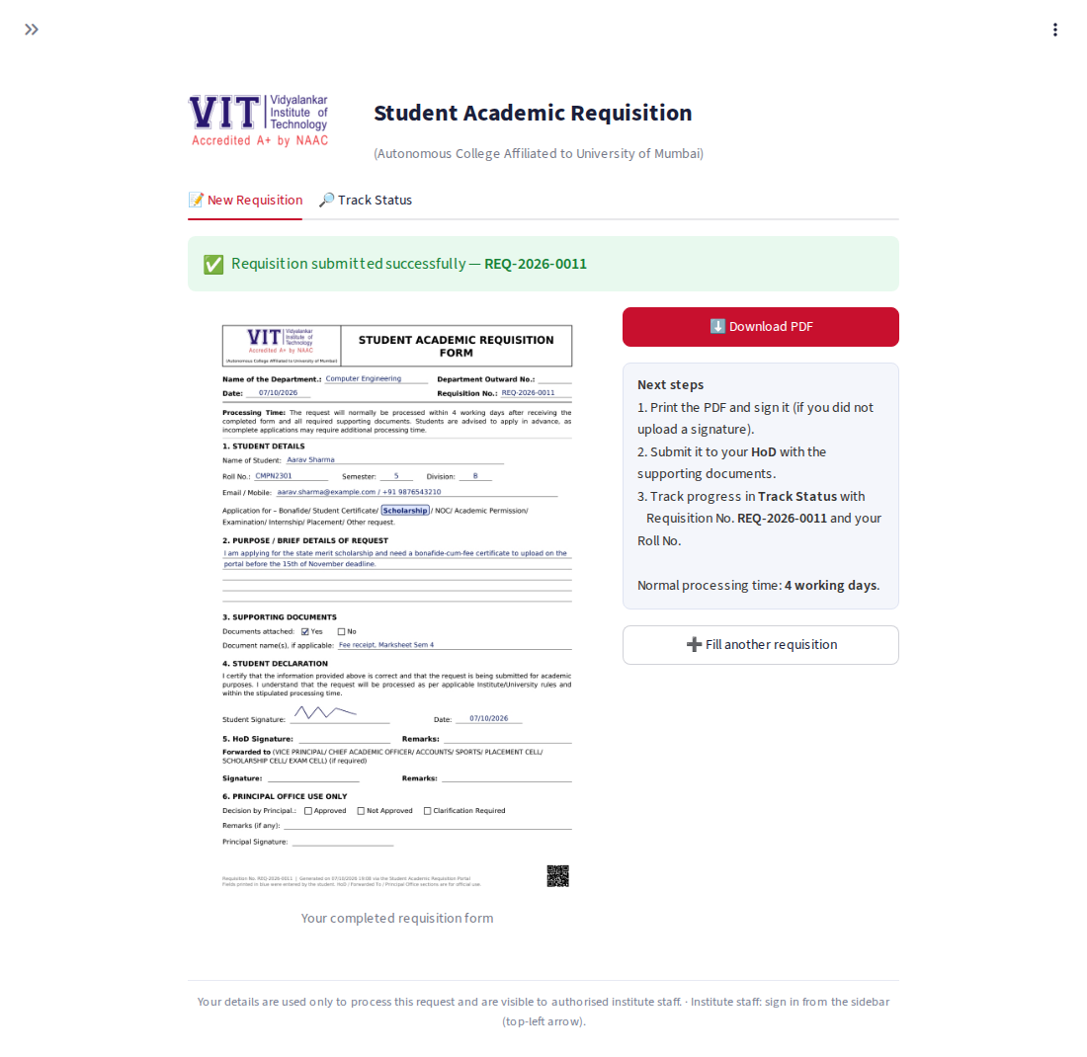
PDF preview and Download PDF button
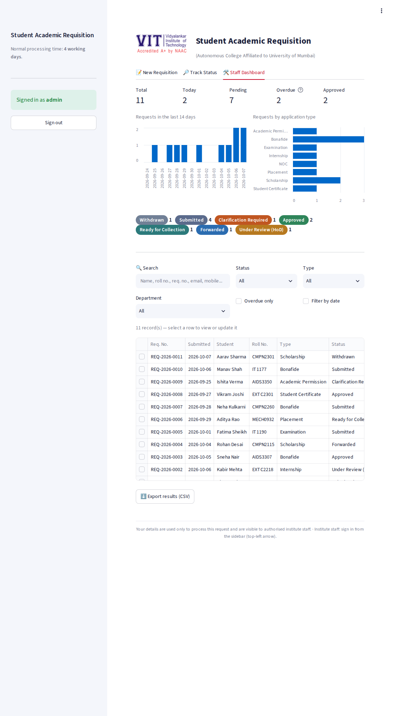
Staff dashboard
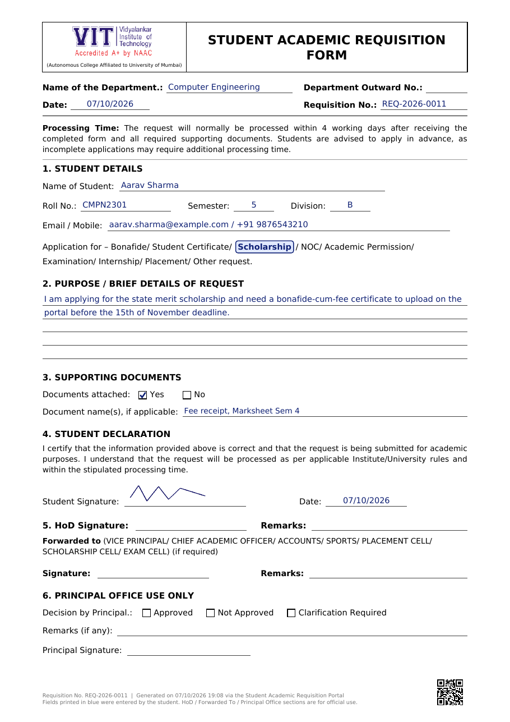
Sample generated PDF

9. Limitations and Future Work
- On free hosting the disk is ephemeral; for production use a persistent volume or hosted database.
- Students are not authenticated (anyone can apply under any roll number); college SSO or e-mail OTP is the production fix. Printed, signed forms remain the legal record.
- Staff roles are flat; per-department HoD scoping and SMS alerts are natural extensions.
- Student signature is an uploaded image; a drawn-signature pad could be added.

10. Conclusion
The application meets all mandatory requirements and several bonus features, producing a single-page PDF that keeps the institute’s requisition format while leaving all official-use fields blank.
Deployed link: ______________________________________

